# Design of ‘Cardiff Nosh’ website

## Introduction

The ‘Very Random Quiz’ website is a trivia quiz, varying in topic and difficulty. If the user answers at least four questions correctly, they are rewarded with a dad joke. If the user answers at least three questions incorrectly, they are punished with an inspirational quote.

### Goals

* Simple layout that is thematically consistent
* Adequately loads a random question every time the button is pressed
* Adequately displays a random quote if three answers are incorrect
* Adequately displays a random joke if at least four answers are correct
* Responsive on various devices

### Design theme

All pages share the same colour scheme—orange (psychologically viewed as eliciting frivolity) and grey with a cream background. All of the text was a sans-serif with a consistent sizing. This layout is aesthetically simple and does not distract from the game.

The logo of the game (A Very Random Quiz) was styled so that it leads to the word quiz. The rest of the logo is grey and smaller, whilst the word quiz is slightly bigger and orange. The word quiz also serves as a link that takes the user back to the home page. The navigation bar is a simple set of links in one line. Visually, it consists of three parts: two navigation bars on either side of the home link. These are laid out horizontally on a desktop and stack up vertically on smaller devices.

Each page also shares the same footer. It too consists of three parts: a link to the home page, a link to the contact page and social media icons nested in the middle. Theoretically, these social media icons will lead to Cardiff Nosh’s Facebook, Twitter and Instagram. However, they do not actually exist, so the footer icons do not lead anywhere.

When hovered over, all of the links turn a slightly transparent version of the main red colour. This was done so that even the logo changes if hovered over. This is demonstrated in the screenshots below.

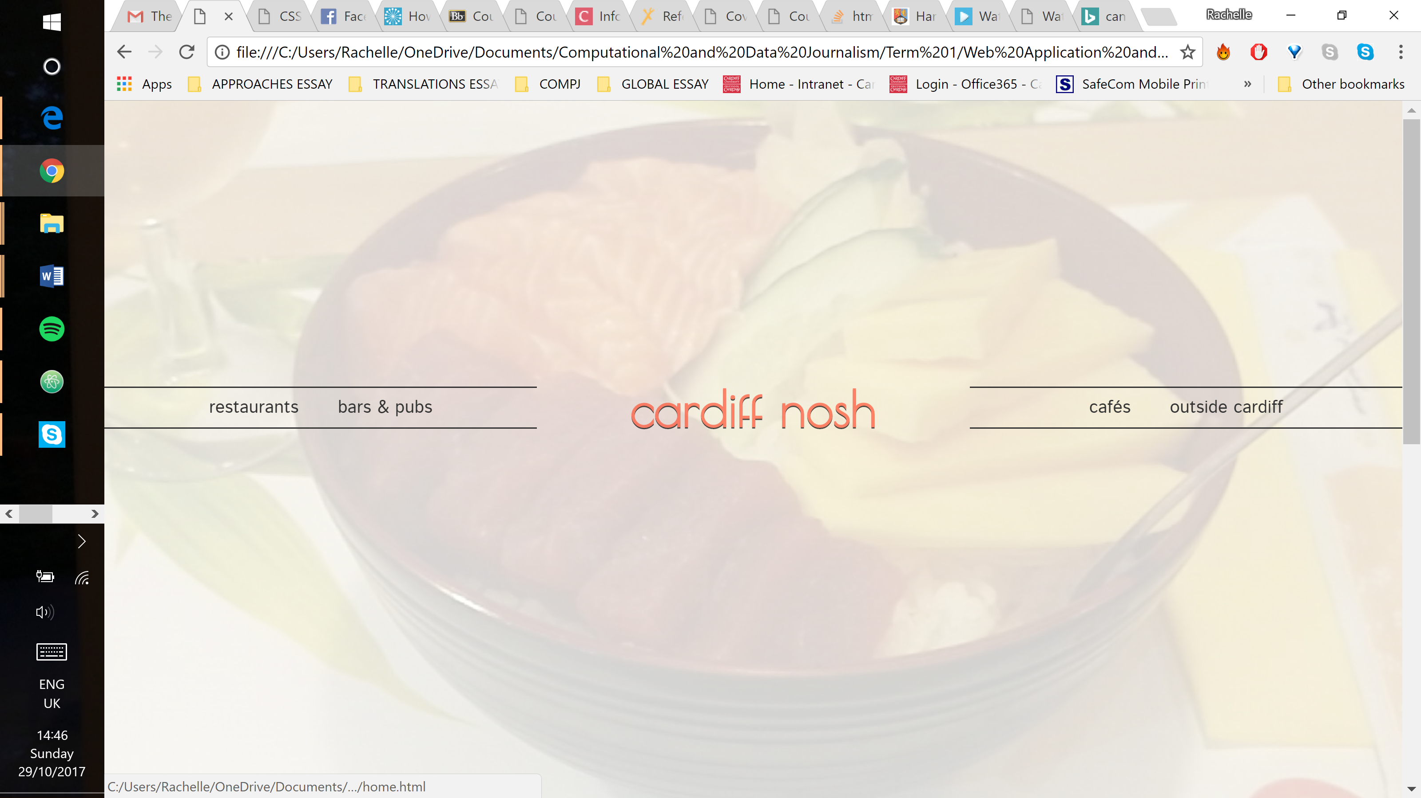

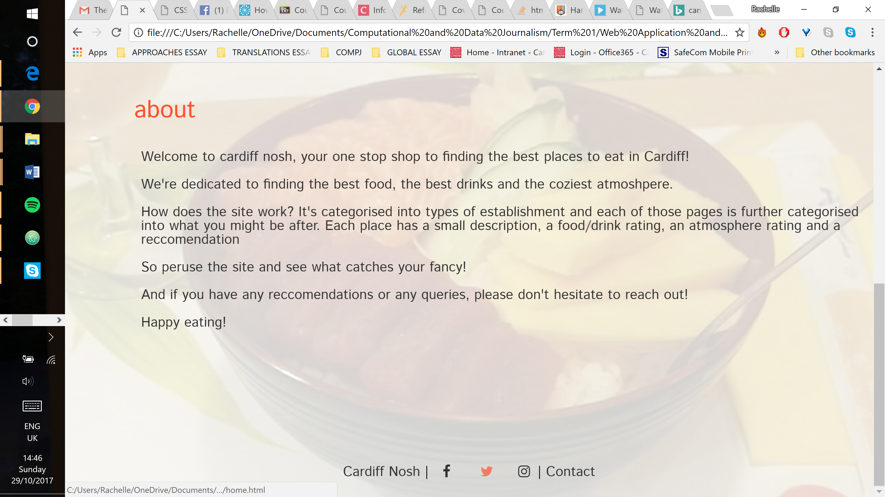

The website was designed so that each ‘chunk’ of content took up the entire screen and could function as a standalone piece.

## Home and contact pages

These are the only pages that have a background image. It was added to make it a bit more interesting as there is little content on these pages compared to the others.

As demonstrated in the screenshot below, the intention of the home page was to have the navigation bar in the centre of the page as the focal point.

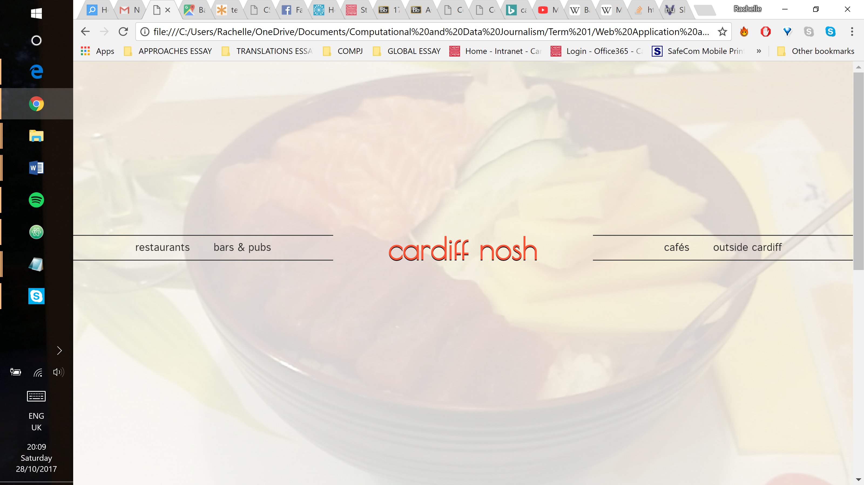

The home page also includes an about section, but this is further down the page. The large space between the two was intentional so that, on most devices, the two were not seen on the screen at the same time. Though there is no indication there is more content further down, the scroll bar should be obvious enough.

The contact page has little content so, for the sake of consistency, it has the same design as the home page. The only difference is that it also has a contact form. The form was built based on a tutorial for a CSS/HTML-only form, without the use of script. The intention is that the user can write in any questions or suggestions. The current contact form can be filled out, but it is not completely functional as it is not connected to an email.

Restaurants, cafés, bars & pubs and outside cardiff pages

These pages follow the same concept as the home and contact pages—simple and standalone sections. However, the design is different. The background image was replaced with a cream background and the navigation bar was moved to the top of the page. The footer remains in the same position. This was designed with the intent that each establishment would be on screen one at a time, as demonstrated in the screenshot below.

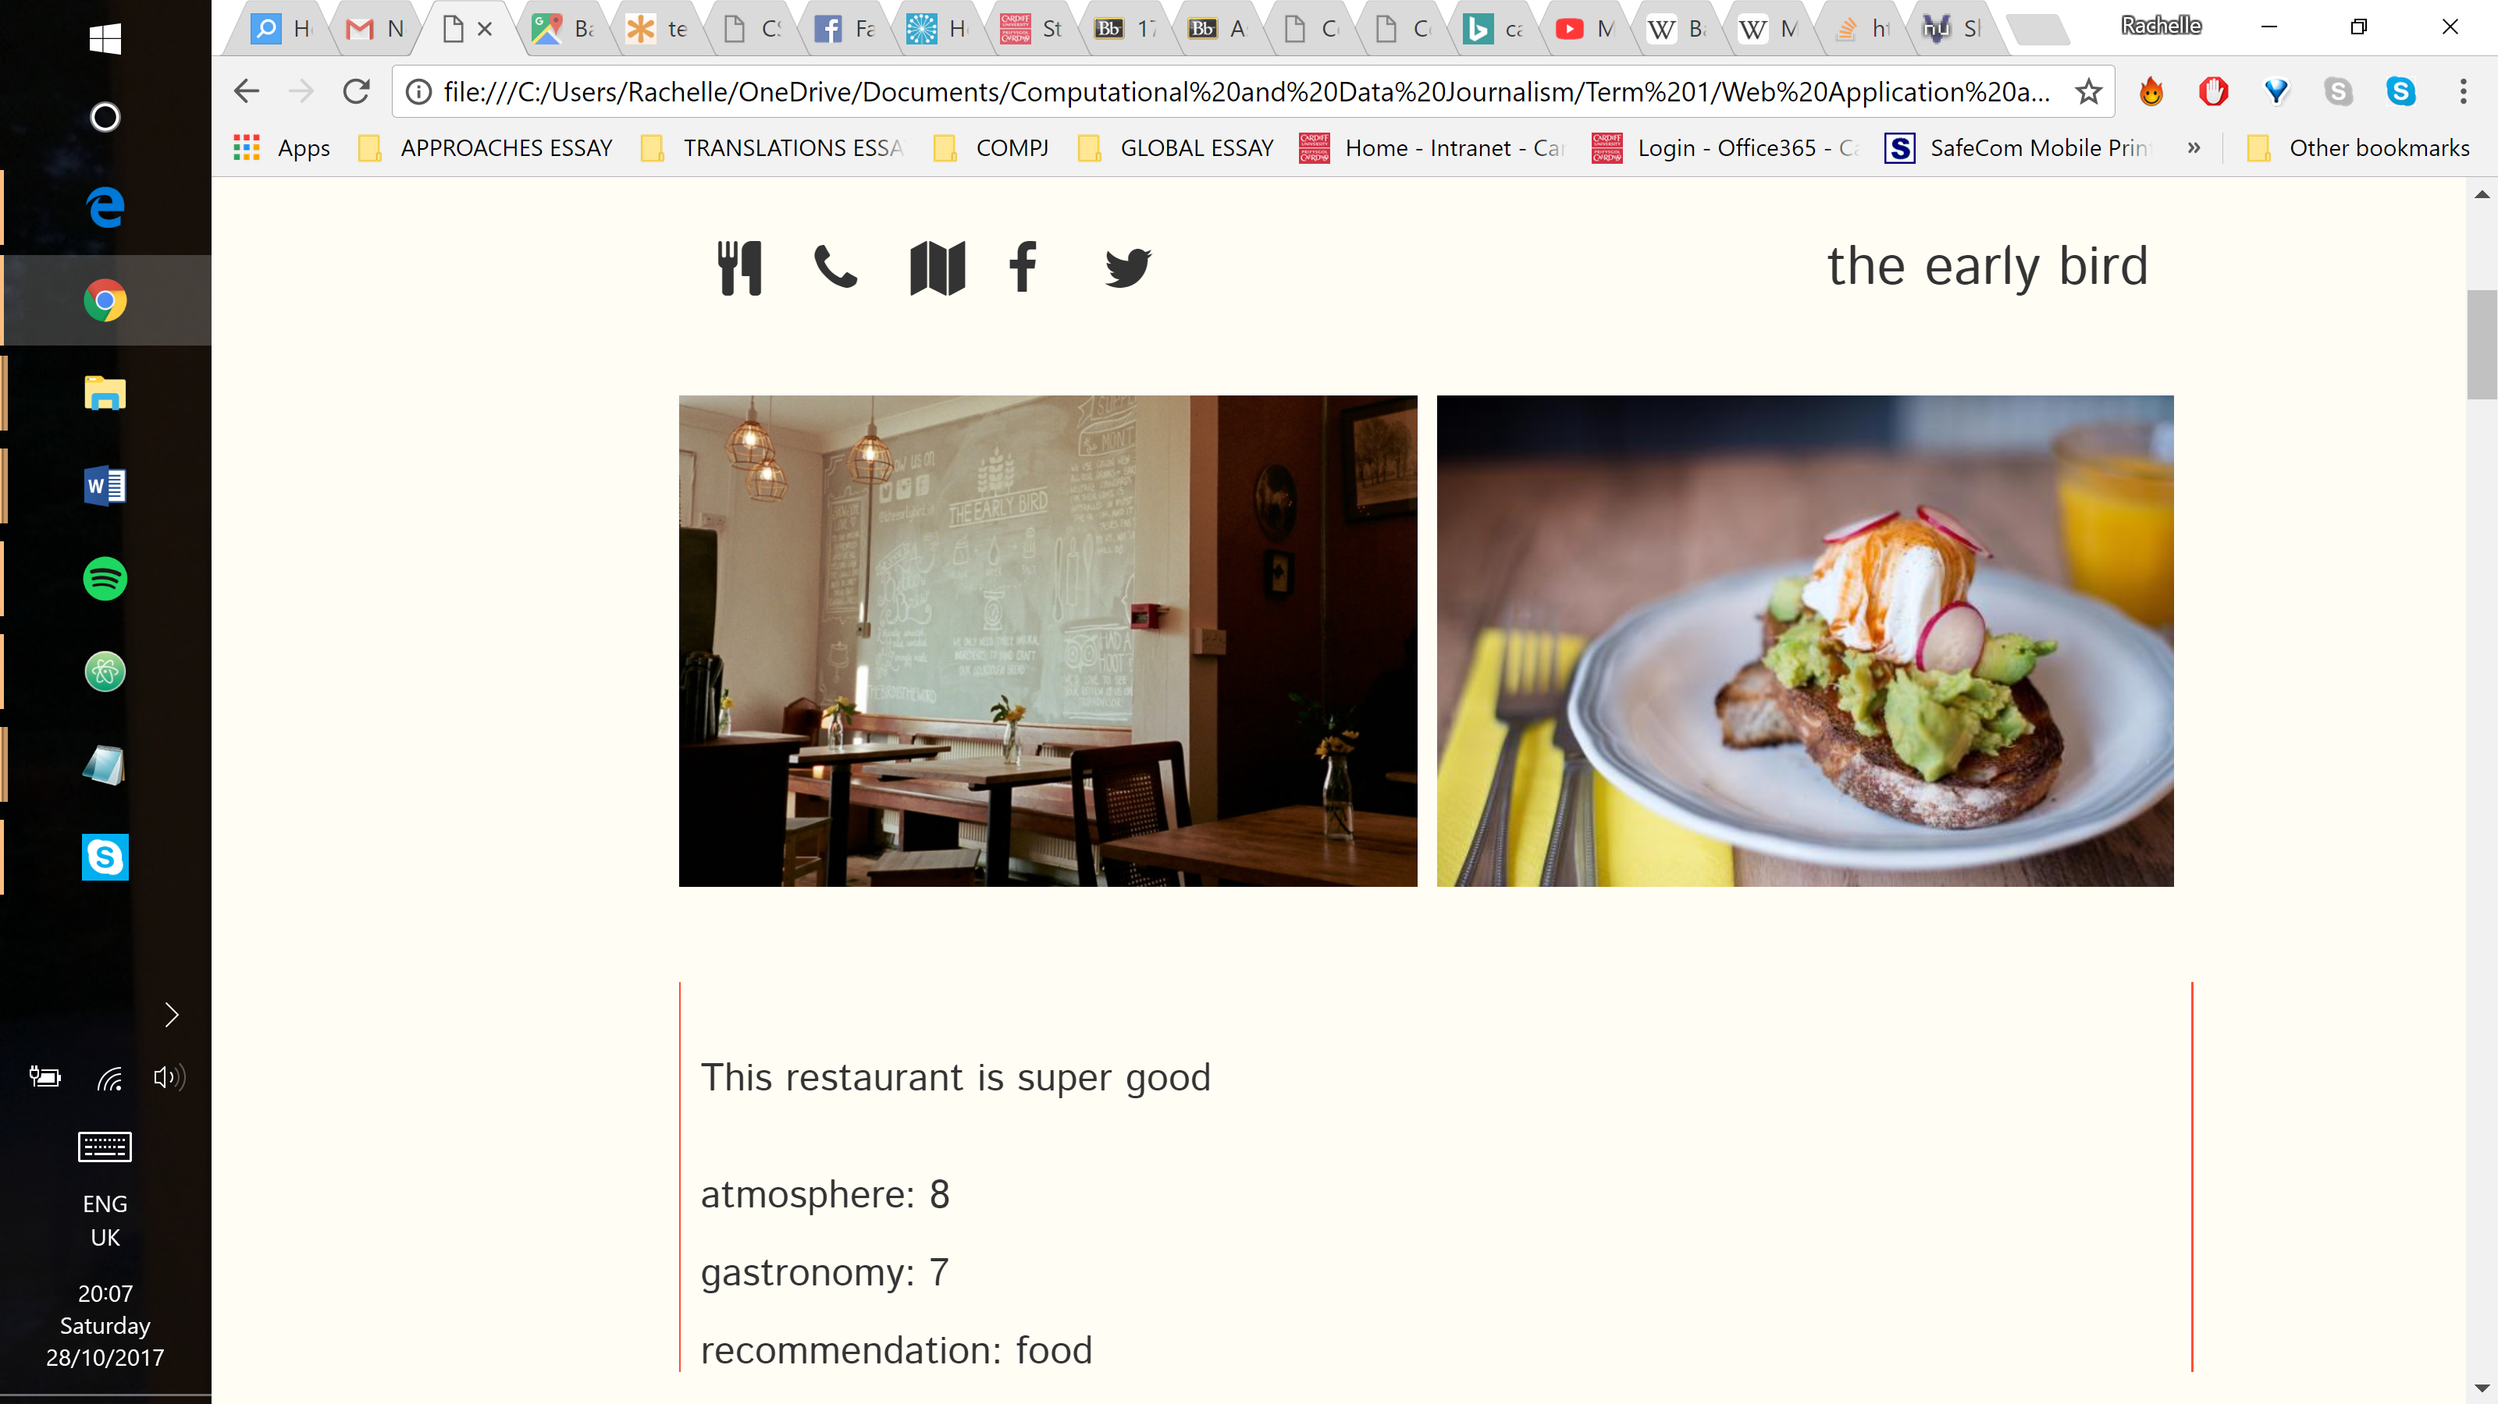

All of the content is within a flexbox column to align them. The images are in a flexbox row so they appear side by side. The written content within the red borders is always in line with the largest image. The establishment name is aligned to the right side of the images with the social media icons on the left-hand side. These icons allow the user to find out more information about the establishment. In addition to social media, the user can view the establishment on Google Maps, call them (on a mobile device and on a computer) and visit the website. The website is linked to an icon representing the type of establishment (a fork and a knife for restaurants, a coffee cup for cafés, a martini glass for bars and a pint for pubs). The social media icons and establishment names were both wrapped in span elements in order to align them with each other and above the images.

In order to make these pages responsive, the layout had to be altered slightly. Just like with the home/contact pages, the navigation bar was rearranged vertically.

The content had to be rearranged as well. The images were restructured into a flexbox column and resized so that they were the same size. Everything else stayed the same, although there was a lot of tinkering to make sure all paddings and margins were resized for a smaller device.

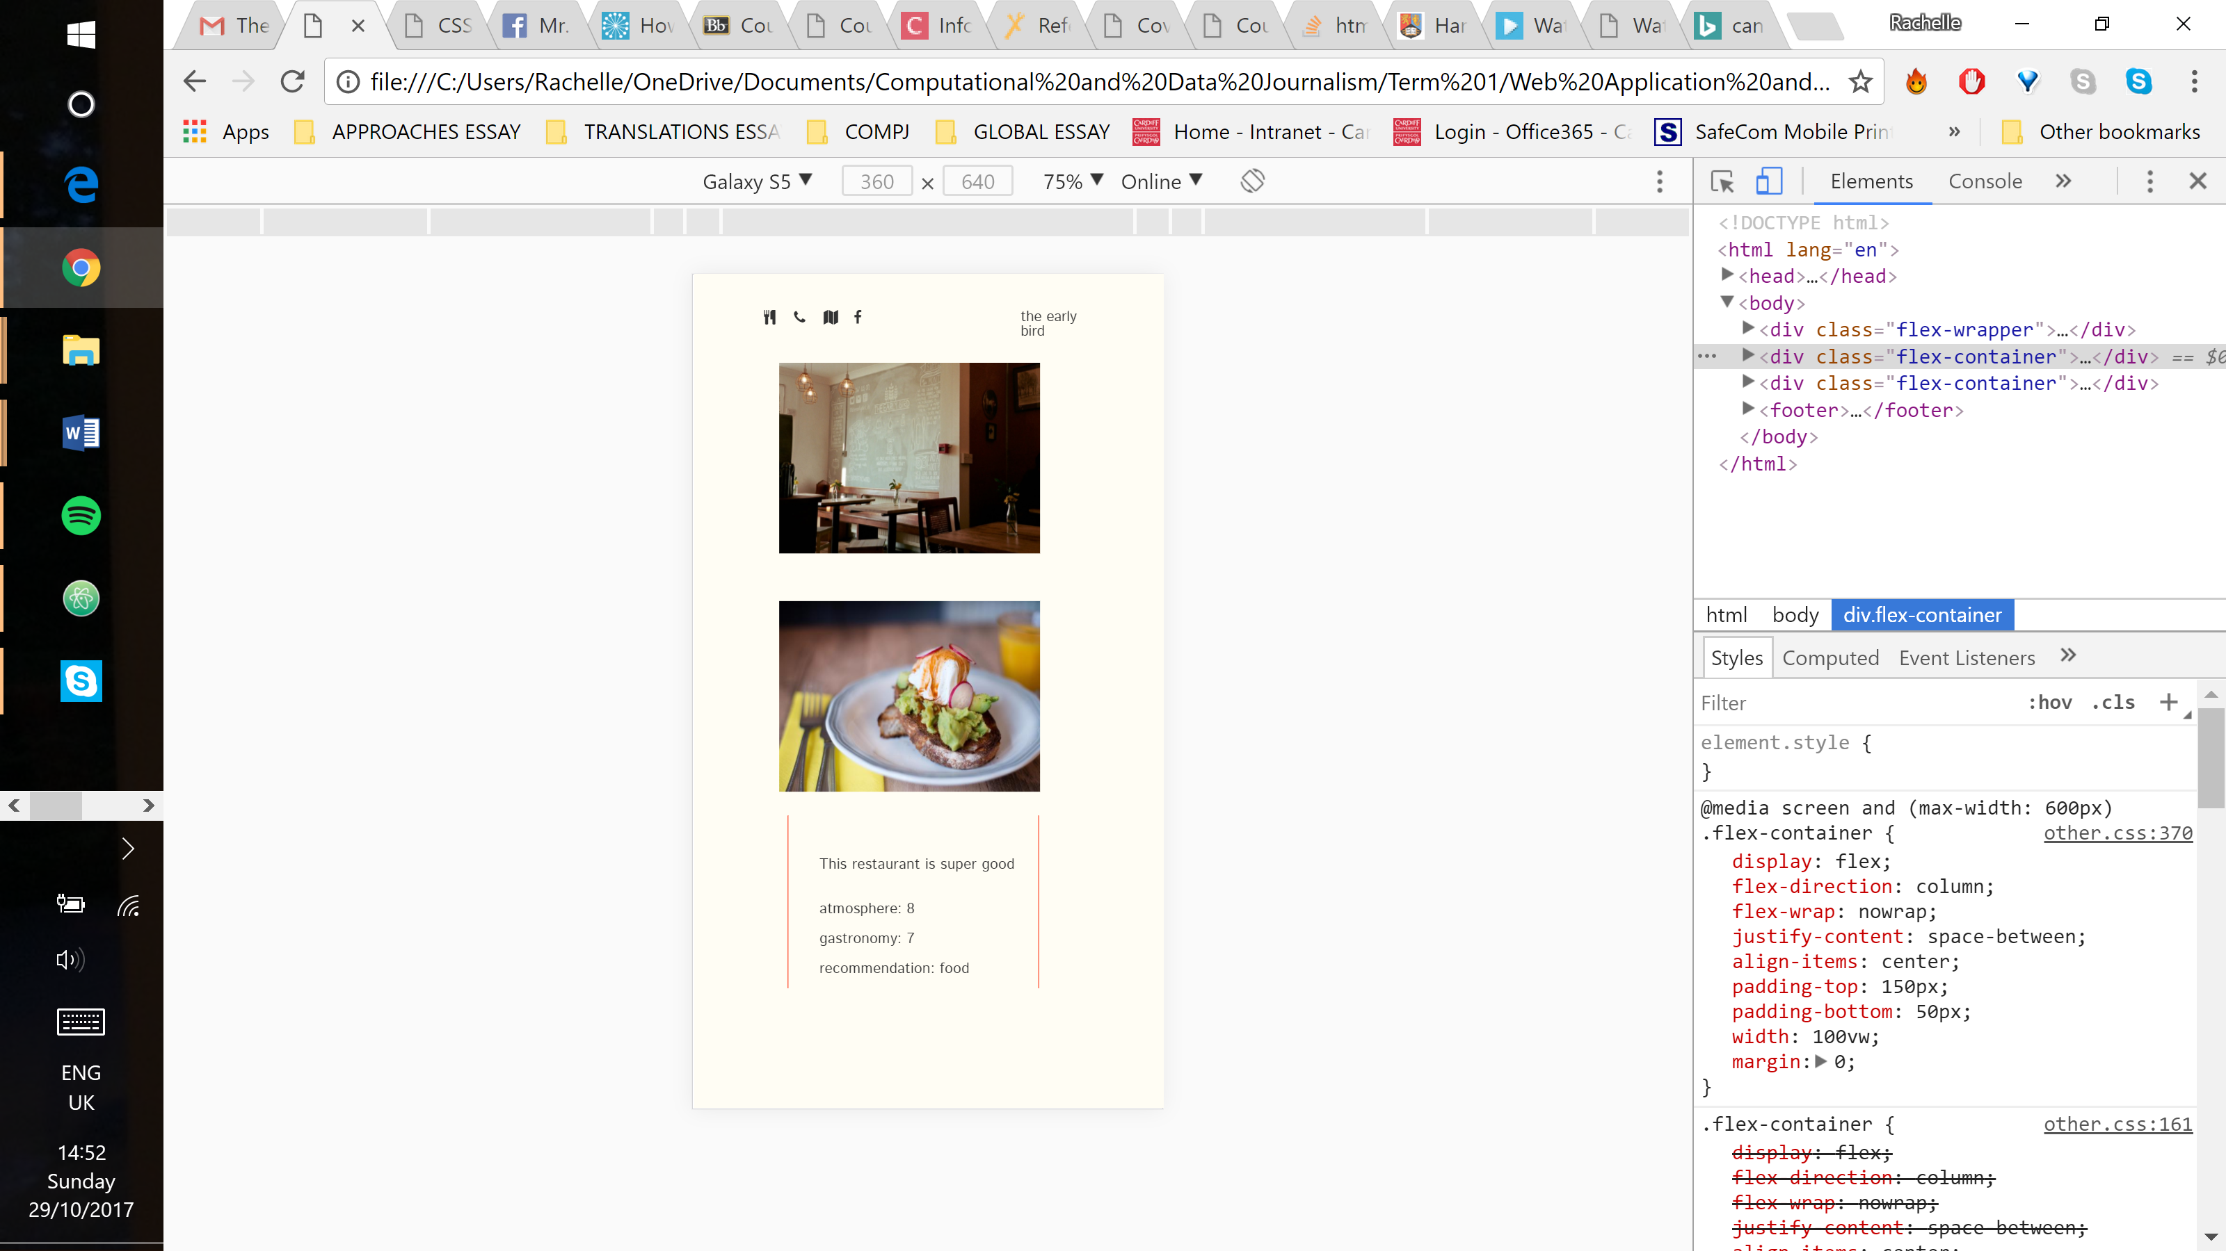

## Validation

### CSS validation

The first issue flagged up was that ‘hidden’ is not an accepted background-color value. This was used to remove the background colour on social media icons and it was successful. The error was ignored.

The only other issue was the aforementioned “parse” error. It is still unknown how to fix this error. The screenshot below is of the other.css file. The errors for the main.css document were the same, bar the “parse” error.

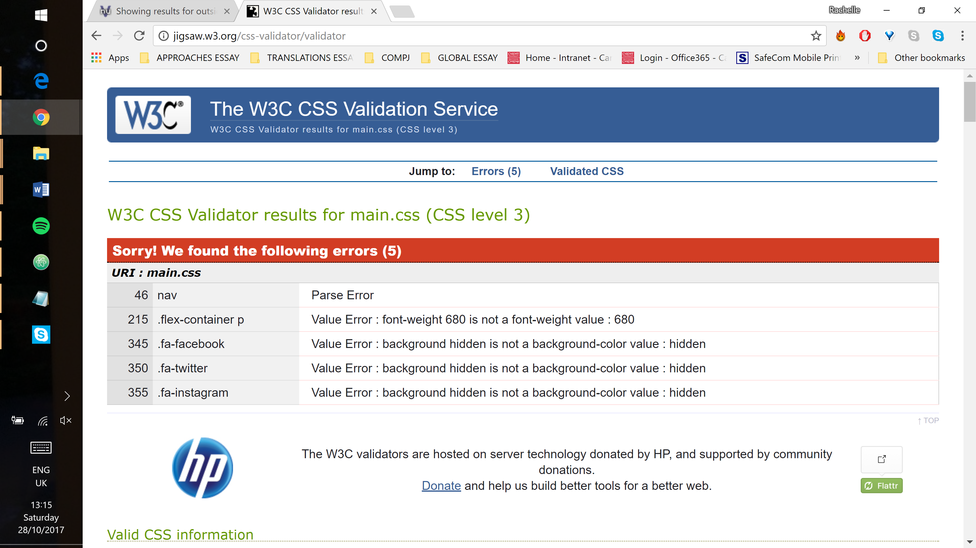

### HTML validation

The first error flagged was that h3 is not allowed as a child of a span element, but this was the only way the layout would work, so the error was ignored.

The only other error was that the h3 heading was empty, but it is not empty, so this error was ignored as well. The screenshots below are from the validation of the rest.html document. The first screenshot has all the same errors as were flagged for home.html and contact.html. The other screenshot shows the errors found on all of the other pages. They repeat several times, so only one screenshot of it has been included.

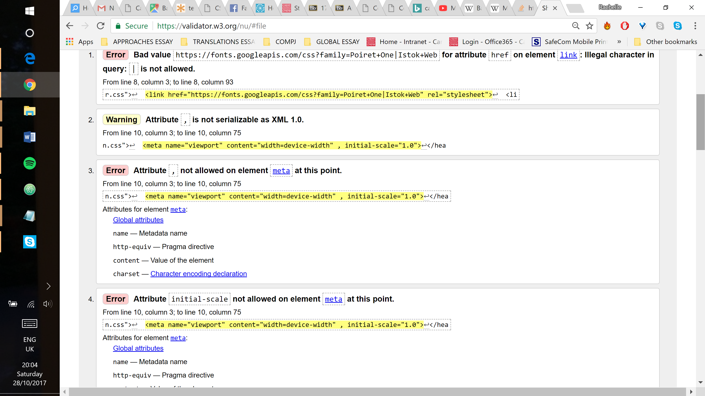

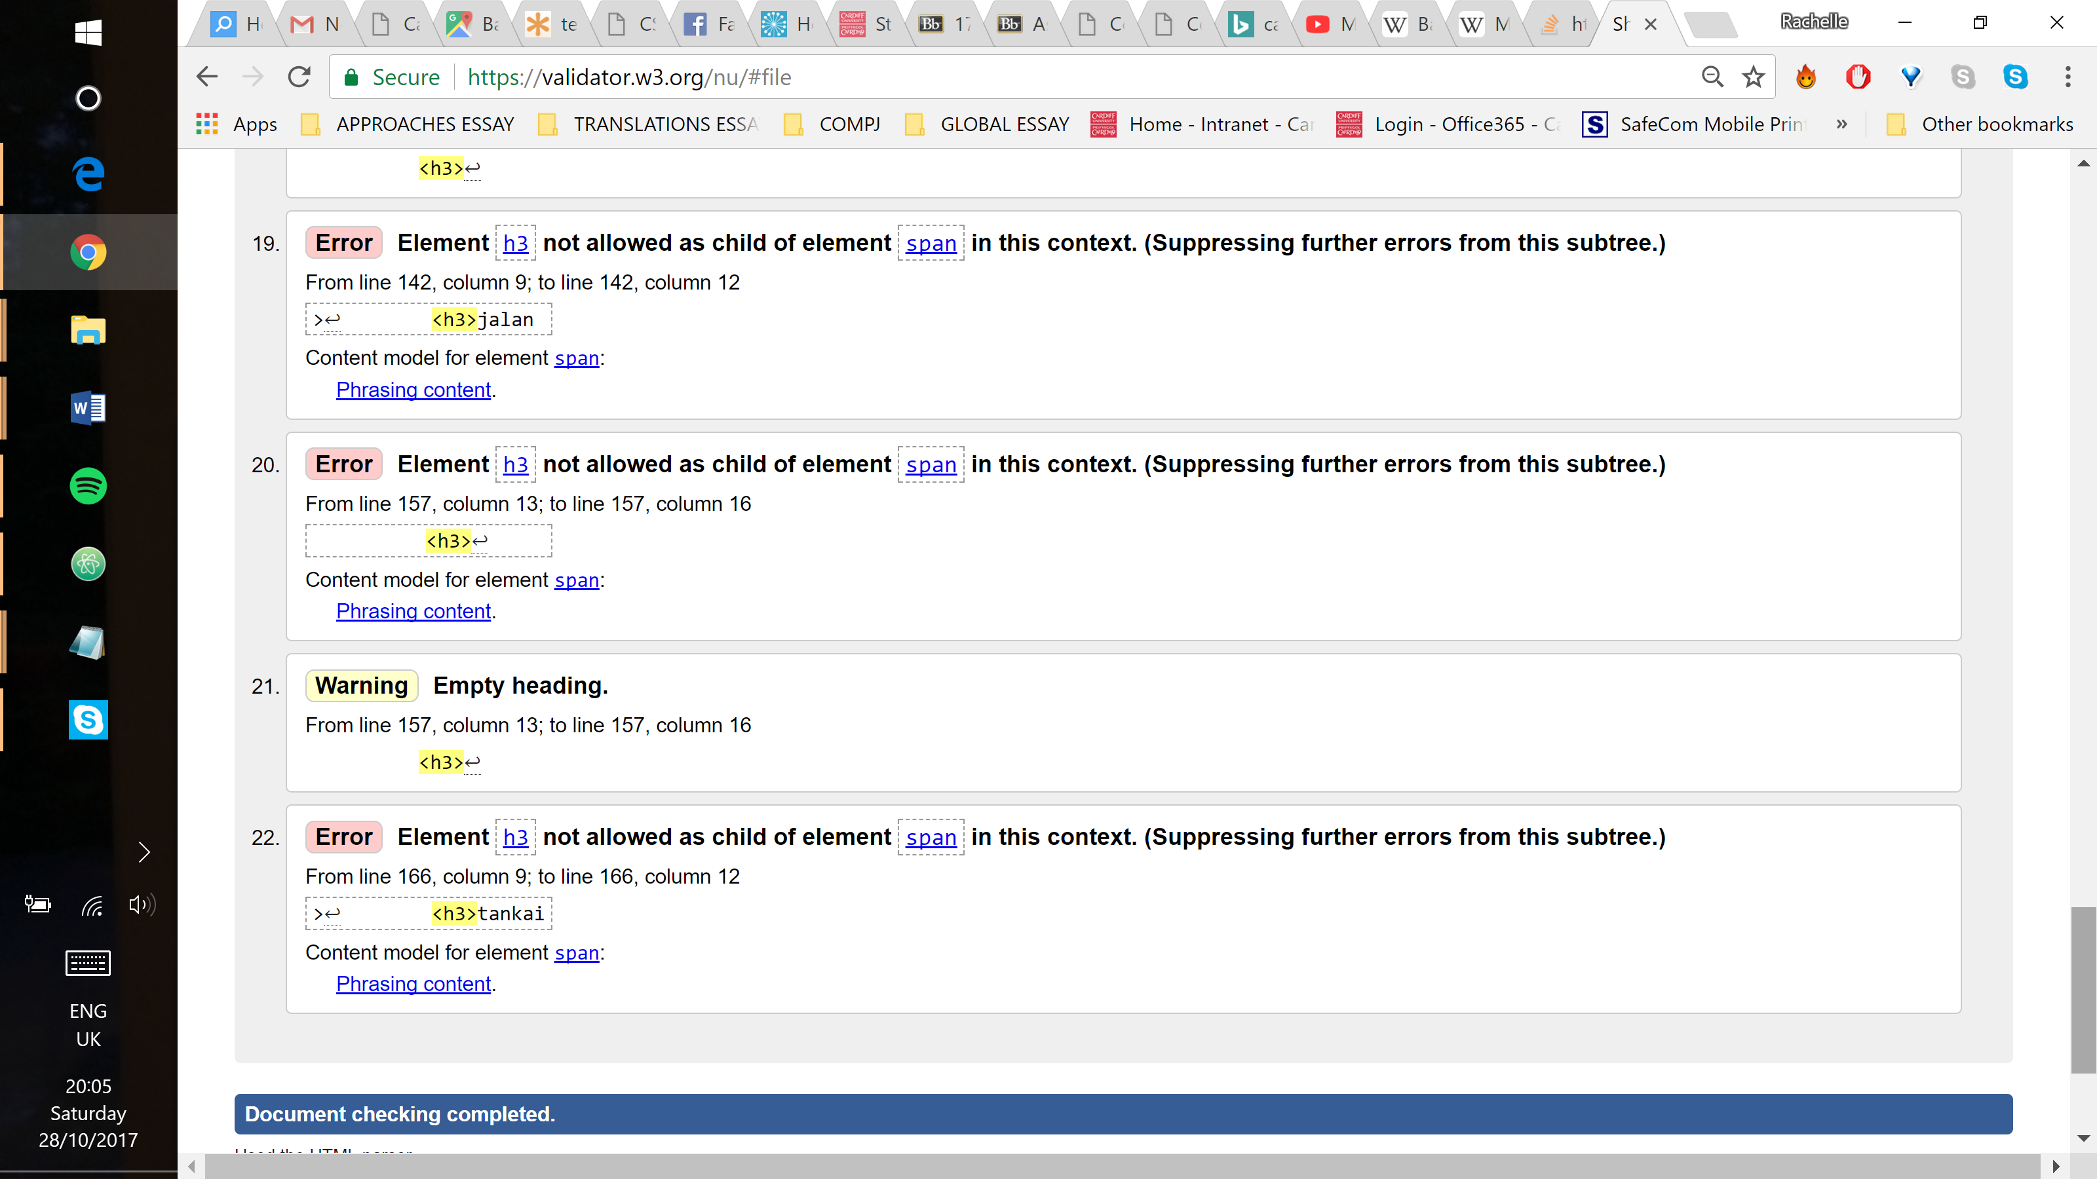

## Evaluation

This website contains five static webpages styled and positioned with CSS elements. Each aspect of the website was produced the way it was intended. Specifically: the navigation bar, the contact form and the layout of the content pages. The website was built using the developer tools to better understand the performance and execution of the code within the browser, verify styles applied to specific elements and emulate other devices.

### Home and contact pages

On the desktop version, these pages appear exactly as intended. However, on a mobile device, there are a few more issues.

The background image would only fill the screen if the width was increased, causing the image to appear zoomed in. No solution was found that would display the entire image and fill the screen.

The footer displays the social media icons a little above the rest of the footer instead of in line with the words as in the desktop version. The screenshot below shows both of these issues.

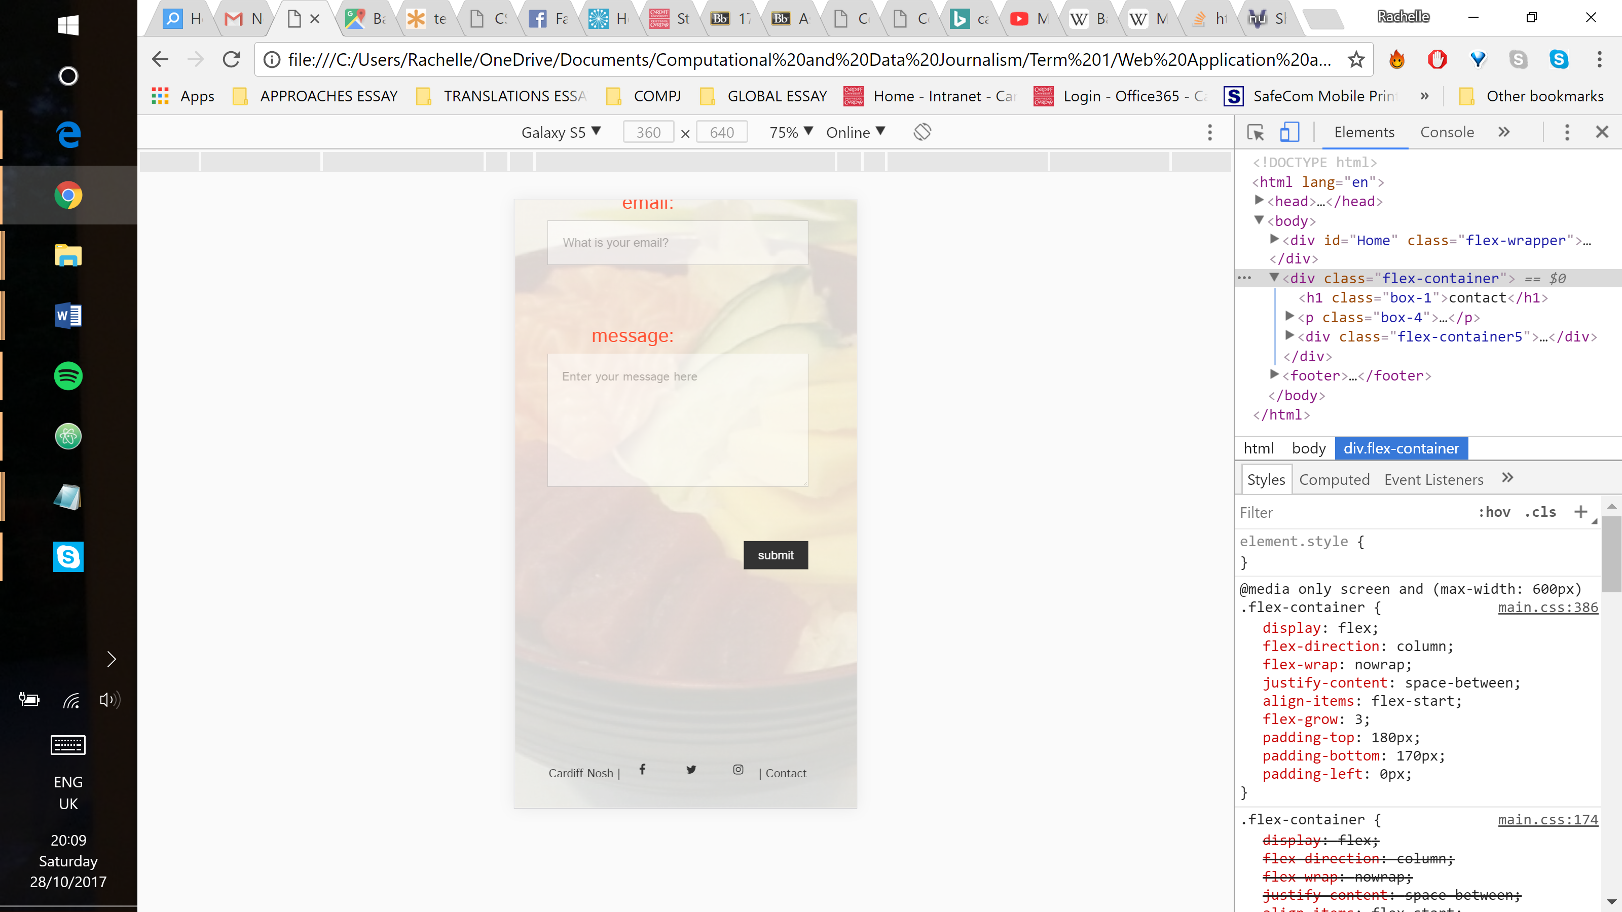

These pages work well on all mobile devices. They work well most of the time on a tablet, except sometimes a horizontal scroll bar will appear. This changes without code modification, so it is, presumably, a browser issue. Below is a screenshot of it without a horizontal scroll bar.

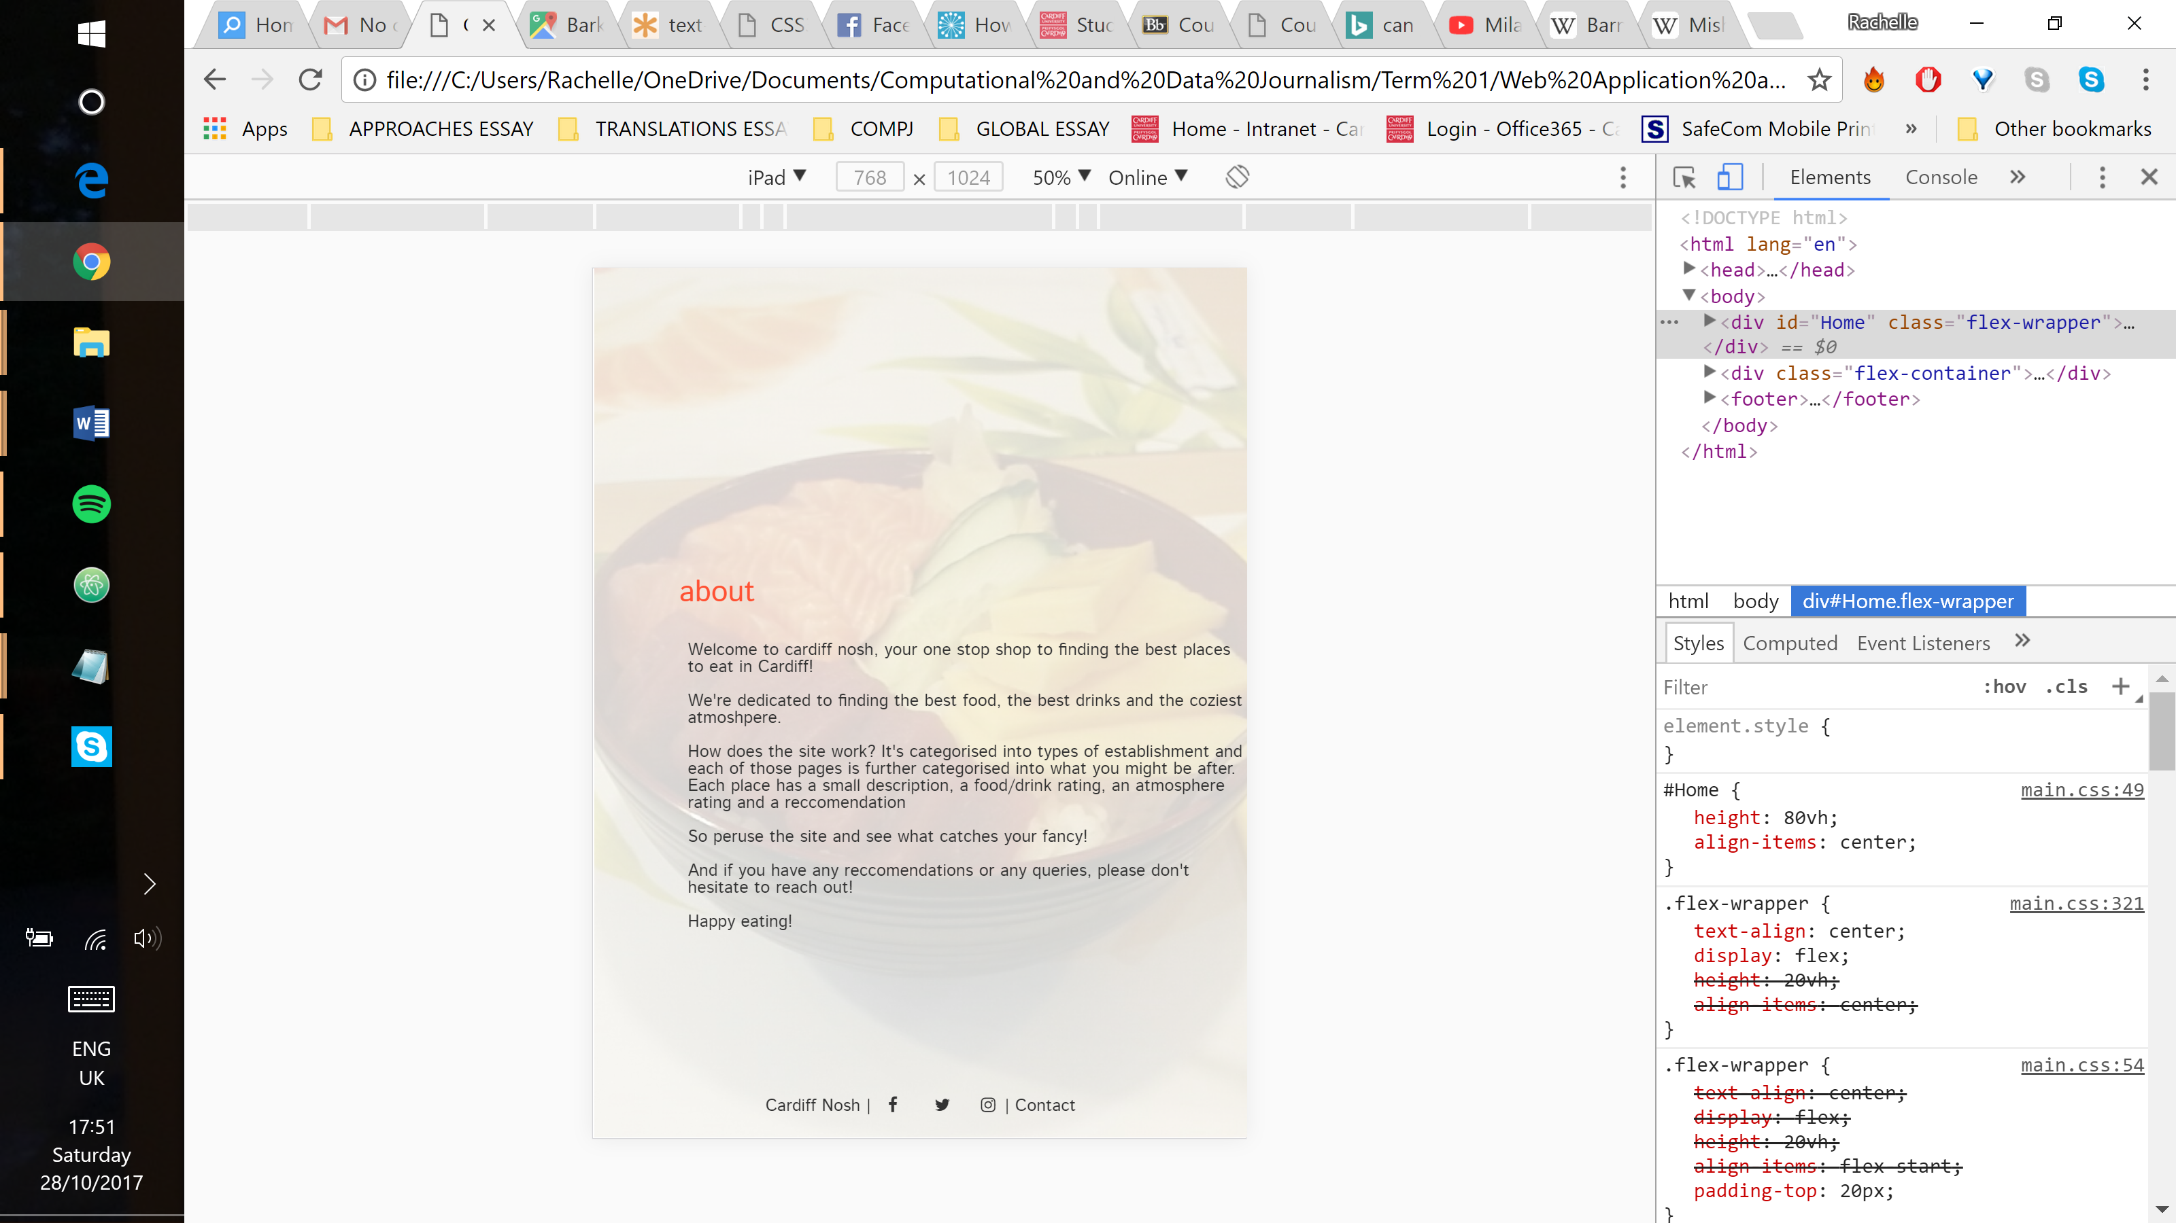

### Restaurants, cafés, bars & pubs and outside cardiff pages

These pages work almost perfectly on a desktop. The only issue is that sometimes the red borders line up with the images and sometimes they are slightly out of alignment. However, this changes without any alterations to the code, so it is presumed to be a browser issue.

These pages were difficult to make responsive. The footer and the navigation bar are off-centre and nothing would move them.

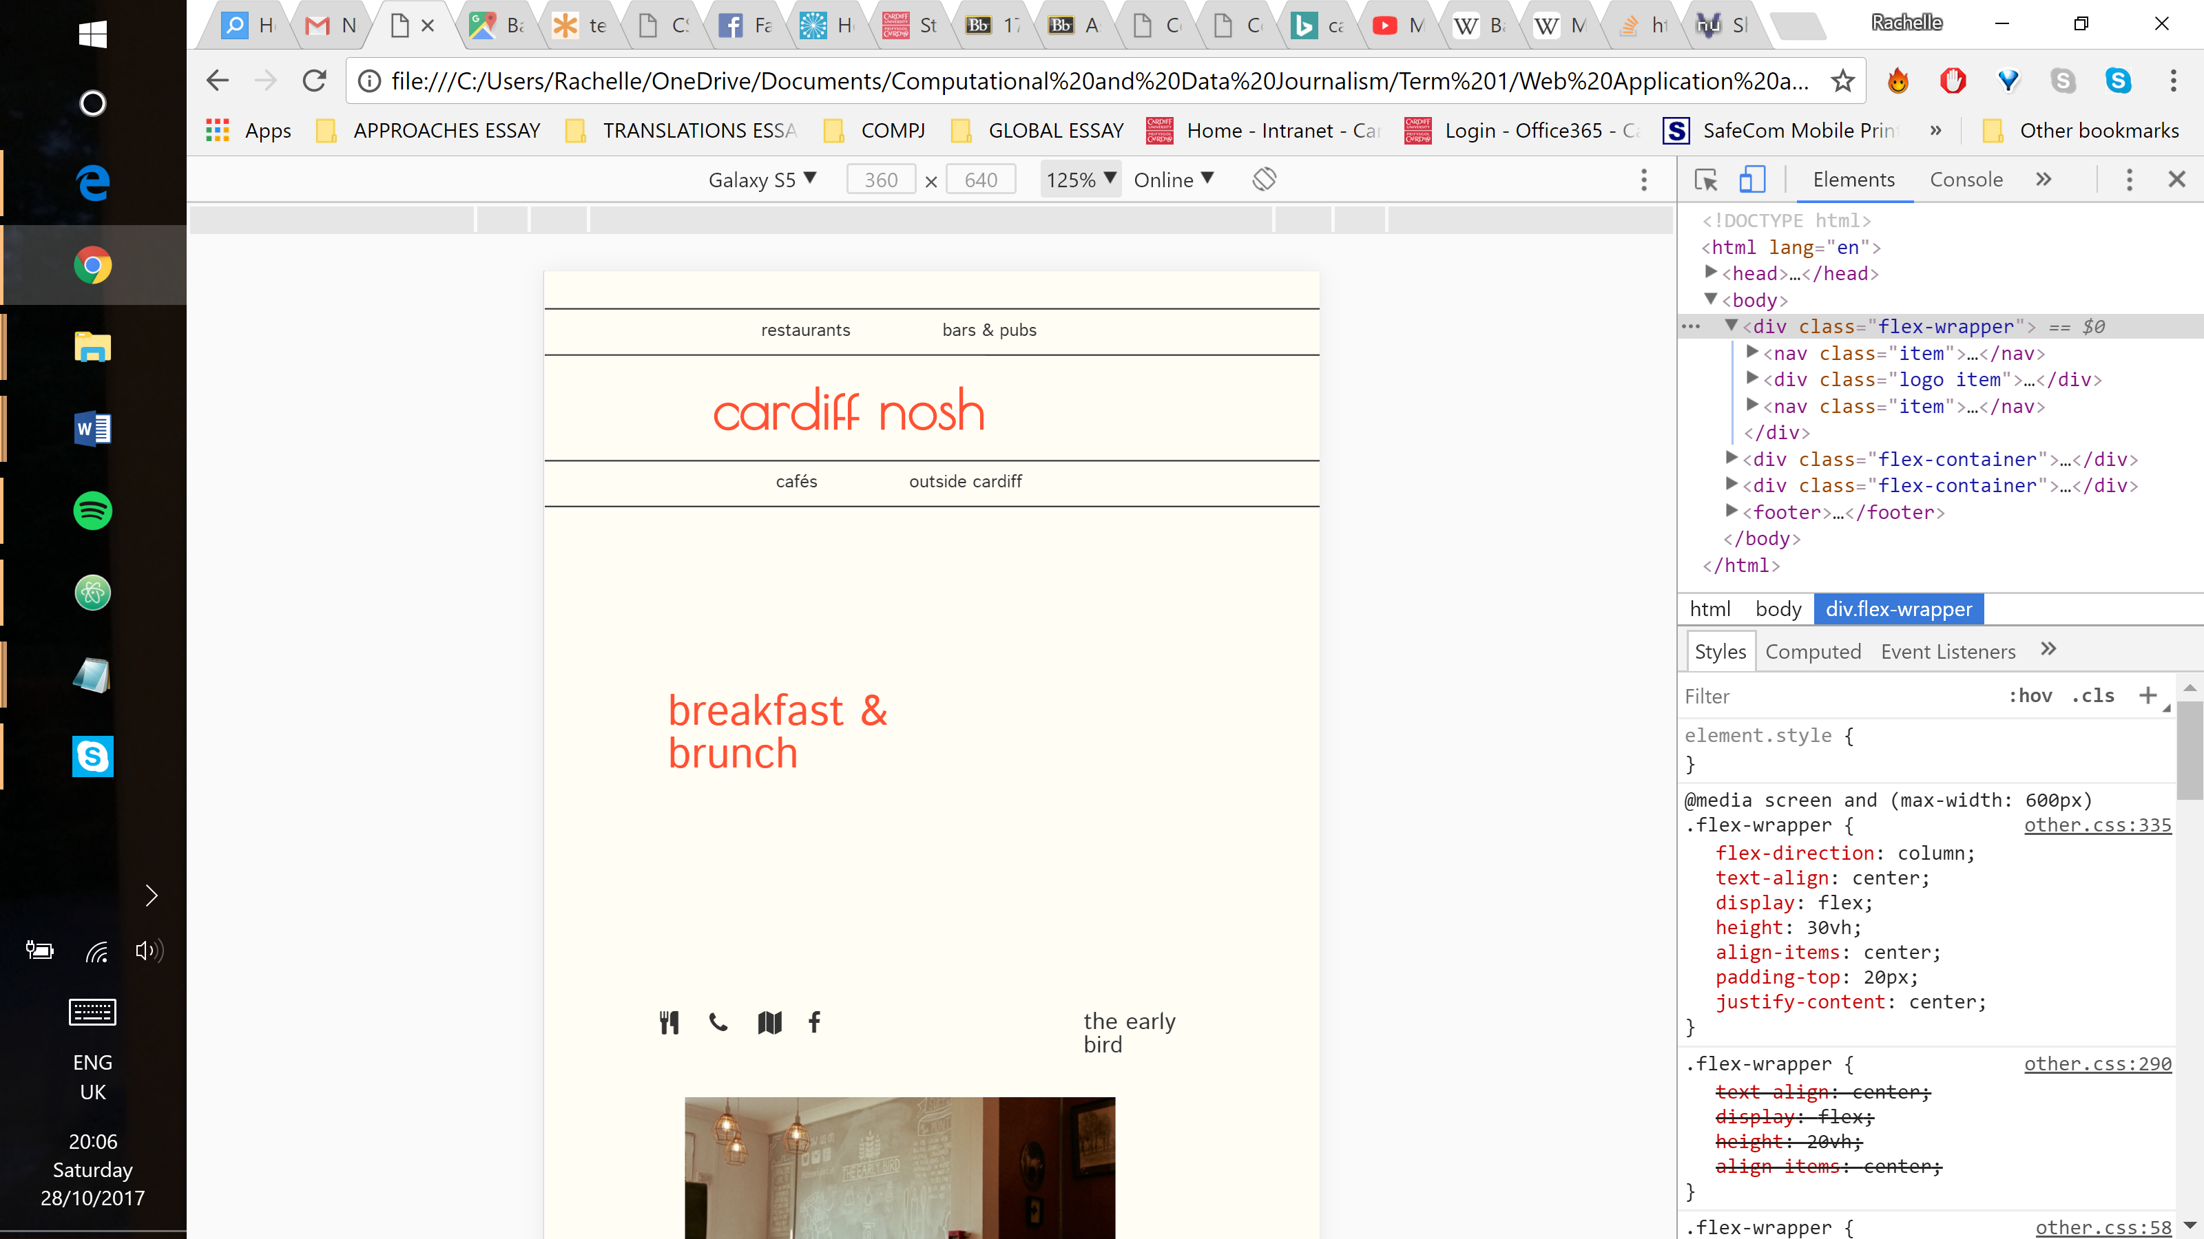 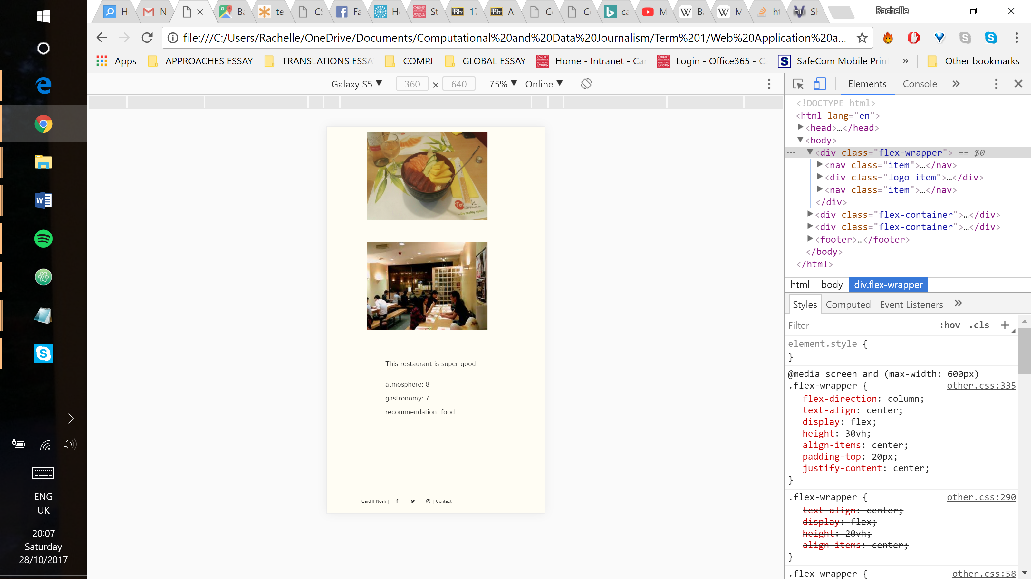

The actual content is slightly off-centre. Whilst adapting to a smaller screen, all of the content was pushed to the left side and off the screen. It is off-centre only slightly, but ideally it would be right in the middle.

When the social media icons were aligned in a row next to the establishment name, the last icon would completely disappear. As seen in the screenshot below, developer tools have demonstrated that it is still there, just invisible.

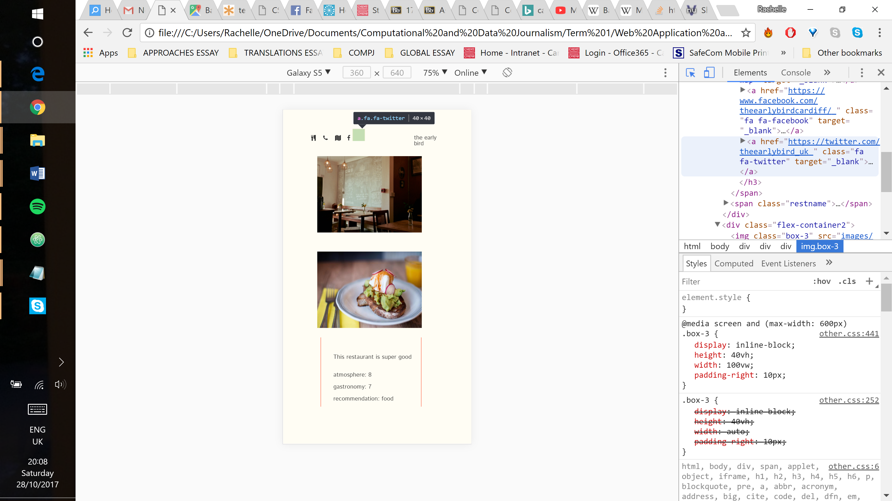

It seems that there is an unfixed chrome bug that is impacting the web font rendering, so it is presumed to be a browser issue. The icon reappears if the icons are stacked on top of each other, but it has been left in line so as to demonstrate the intended style.

These pages are not responsive on an iPad (home and contact are). For some reason, it will not register the CSS media query for it, no matter what was attempted. Validation flagged up a “parse” error right after the final media query which could be the cause, but there was no apparent solution to this error

### Conclusion

Overall, this website, the code and the process of building it demonstrates an apt knowledge of HTML and CSS as well as an improved ability to find and troubleshoot bugs, though not always with success. The process would be sped up if the code was consistently confirmed to be working properly and a more meticulous attention to detail. If the exact same website were to be reconstructed, it would be done with simpler code and less flexboxes as there is now a better understanding of when they are necessary.